The Effect of pH on Yeast (Saccharomyces cerivisae) Alcohol Production in Beer

Brian Neville and Saman Hashemi
Department of Biological Sciences
Saddleback College
Mission Viejo, California 92692

The brewing process and production of alcoholic beverages occurs on a global scale every day. However water quality and pH levels vary from region to region (Naumburg et al, 2001). This study investigated the effects of pH on alcohol production by weight of yeast (Saccharomyces cerivisae). It was hypothesized that alcohol production in beer was affected by the pH of the solution in which the yeast was fermented. The yeast was fermented in four pH buffered solutions (3, 5, 7, 9). The percentage of alcohol content was calculated by measuring the specific gravity of the solutions before and after the fermentation process. At pH 3, the average alcohol by weight (ABW) percentage was 3.788% ± 0.026% (±SEM, N=5); at pH 5, the average ABW percentage was 4.370% ± 0.026% (±SEM, N=5); at pH 6, the average ABW percentage was 3.761% ± 0.026% (±SEM, N=5); at pH 8, the average ABW percentage was 3.141% ± 0.058% (±SEM, N=5). ANOVA test run on the data, which indicated a significant alcohol production amount among the different pH groups (p=1.225x10⁻¹²). A Post Hoc (Bonferroni Correction - Multiple Comparison) was run resulting in a significant difference of alcohol production between pH: 3 and 5, 3 and 8, 5 and 6, 5 and 8, 6 and 8.
I suggest to change the sentence to “Anova analysis was used to indicate that there was a significant alcohol production among the different pH groups.”

Remove? Replace it by “A post hoc analysis stated that there was a significant difference…
A post Hoc analysis
Introduction
Beer is the world's most widely consumed and probably oldest alcoholic beverage (Hornsey, 2004). Brewing of beer is commonly done both privately and industrially. Due to this worldwide interest in beer, the beer brewing industry is estimated to be worth over $100 billion annually (Munching, 1997). The minerals in the water give distinct flavors to regional beers but the pH may also influence the alcohol level content of these beers. It has been shown already that temperature has a significant influence on the amount of alcohol production (Pinal et al, 1997). At low enough temperature the fermentation process and alcohol production can be stopped and is used to make some non-alcoholic beers (van Iersel et al, 1995). The third factor contributing to alcohol production is the amount of sugars they have to digest in the liquid and the yeast’s tolerance to alcohol content (Casey et al, 1984; O'Leary et al, 2004). Interestingly, pH is not commonly referred to as a parameter that is controlled or used in the beer brewing process. This study will assess the effect that an array of pHs has on the fermentation process by measuring the impact it has on the yeast’s alcohol production efficiency. The study will also determine if there is a significant effect that high or low or even neutral pH values have on the process. Implications from this study could cause brewers and brewing companies to pay more attention to the pH levels of local water and its affect on the desired alcohol level content of the beers.
Add a comma “,”
This sentence doesn’t make sense. “… the fermentation process and alcohol production would be abandoned; This technique is used to make non-alcoholic beer beverages.
Singular? “sugar”
Remove?
I suggest to reconstruct the sentence to “ The study will also determine whether different pH concentrations will affect the alcohol production process.

Materials and Methods
The experiment began on 27 October 2011 and continued through 11 November 2011. Buffered pH solutions (3, 5, 7, and 9) were made by emptying five pHydrion dry pH buffer capsules, made by Micro Essential Labs, into 500 mL of deionized water and stirred until completely dissolved. The pH buffer was provided by Saddleback College Department of Biology (Mission Viejo, CA).
The procedure for the brewing process followed Palmer’s (2006) techniques. One hundred fifty grams of dry malt extract, purchased from O'Shea Brewing Co (Laguna Niguel, CA), was added to each pH buffered solution (3, 5, 7 and 9) and heated until completely dissolved. After the solution cooled to room temperature, a triple scale hydrometer, made by Brewcraft and purchased from O'Shea Brewing Co, was used to measure the initial specific gravity of each solution. The pH was checked for accuracy with ColorpHast pH dipstick strips ranged from pH 0-14 provided by Saddleback College. Each solution was then divided into 5 separate 125 mL Erlenmeyer flasks with 100 mL of solution each to create 20 flasks total.
A solution containing 11.5 grams of the yeast (Saccharomyces cerivisae), purchased from O'Shea Brewing Co, and 100 mL of deionized water was made. 5 mL of the yeast solution was pitched into each of the 20 Erlenemeyer flasks. Between each pitching, the yeast solution was mixed for 20 seconds by swirling to ensure a homogeneous solution. The flasks were sealed with Reynolds Wrap aluminum foil (2.5 in x 2.5 in squares) and allowed to ferment for 2 weeks at about 19°C in Mission Viejo, CA at researcher Brian Neville’s residence. The temperature and pH was measured every other evening to ensure a constant fermentation temperature and to monitor the pH of the solutions. The flasks were sealed with Reynolds Brand aluminum foil (2.5 in x 2.5 in squares) and allowed to ferment for 2 weeks at about 19°C. Final specific gravity readings for all 20 flasks were then taken at room temperature. The percentage of alcohol by weight (ABW) in each flask was calculated as shown by the following equation:
I suggest to reconstruct the last sentence. For example: each group was then divided into five, each containg 100 mL of the solution which were then poured into 125mL Erlenmeyer flasks.
No comma
pH “value”
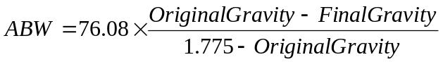

Results
The percentage of the alcohol by weight as a result of the fermentation was averaged and graphed (Figure 1). At pH 3, the average alcohol by weight percentage was 3.788% ± 0.026% (±SEM, N=5); at pH 5, the average alcohol by weight percentage was 4.370% ± 0.026% (±SEM, N=5); at pH 6, the average alcohol by weight percentage was 3.761% ± 0.026% (±SEM, N=5); at pH 8, the average alcohol by weight percentage was 3.141% ± 0.058% (±SEM, N=5). ANOVA test was run on the data, which indicated a significant alcohol production amount among the different pH groups (p=1.225x10⁻¹²). A Post Hoc (Bonferroni Correction - Multiple Comparison) was run resulting in a significant difference of alcohol production between pH: 3 and 5, 3 and 8, 5 and 6, 5 and 8, 6 and 8.
Repetitive. Make correction to the sentence construction.

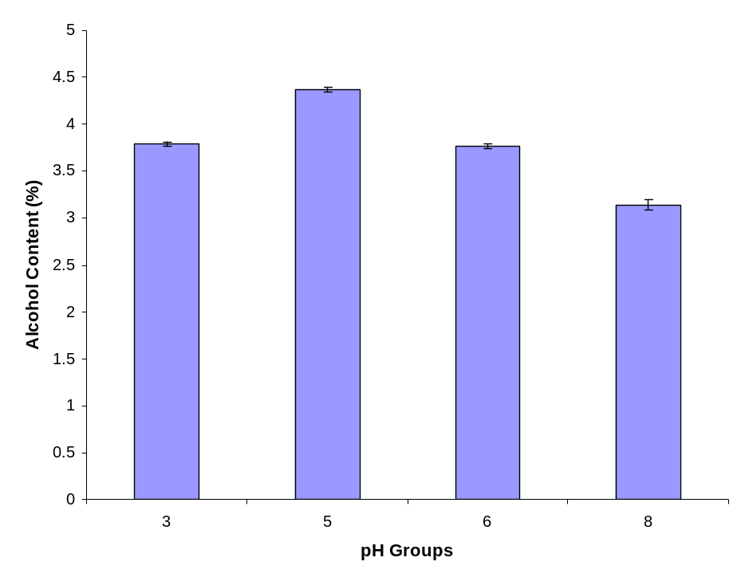
Figure 1. The mean alcohol by weight percentage after fermentation of the yeast Saccharomyces cerivisae in pH 3, 5, 6, and 8. ANOVA shows a significant difference (p=1.225x10⁻¹²). Error bars indicate mean ± SEM.
Discussion
Singular

The results showed that the different pH buffered water had a measurable effect on the alcohol output of the yeast. The pH 5 buffered water yielded the highest alcohol levels out of the four experimental groups. The pH 5 solution had a 40% greater alcohol content greater than the pH 8 buffered solution, which was the lowest yielding alcohol fermentation group. The solution with a pH of 3 is two units away from our optimal pH for alcohol production, however, it produced a similar alcohol production level as the solution with the pH of 6 that is only one unit away from optimal pH. This indicates that the yeast prefer a more acidic environment over a basic and neutral environment (Dequin, 2001). This indicates that the yeast have a nonlinear relationship with pH and the alcohol that is produced, and for every unit moved toward the basic side of the pH spectrum alcohol production exponentially decreases (Nagodawithana and Steinkraus, 1976).
Doesn’t make sense. Make adjustment to construction.
It would then come to reason that when brewing, adjusting the pH of the water could be a beneficial tool in controlling the alcohol content that is desired in the beer (Nevoigt et al, 2002). This study could have been improved by running alcohol monitoring sensors to measure the exact rates the yeast produces in real time for each of the solutions rather than only measuring initial and final end results by with a triple scale hydrometer. This would give a clear indication of how the pH effects fermentation throughout the process due to the supposedly accuracy of the instrument (Pilkington et al, 1998). The initial pH levels in the yeast solutions of pH 7 and 9 dropped to pH 6 and 8 respectively after the completion of fermentation. This shows that the acidity levels produced to be high in order to overcome the buffer in the yeast solution.
Affects?
Smaller increments of pH could also be used near the pH of 5 to pin point more clearly what the optimal pH fermentation would be in order to further optimize alcohol production. Also a wider pH rage may be tested in the future to determine the pH cutoff for yeast fermentation.
Range

Acknowledgements
The authors wish a special thanks to Professor Teh for the help and support for this project, and to the Department of Biology at Saddleback College for providing the tools necessary for completion of the project.

Literature Cited
Casey G. P., Magnus C. A., & Ingledew W. M.. 1984. High-Gravity Brewing: Effects of Nutrition on Yeast Composition, Fermentative Ability, and Alcohol Production. American Society for Microbiology 48:639-646

Dequin S. 2001. The potential of genetic engineering for improving brewing, wine-making and baking yeasts. Applied Microbiology Biotechnology (2001) 56:577–588

Hornsey, I. H. (2004). History of beer and brewing. (1 ed., p. 32). England: Royal Society of Chemistry.

Munching, P. V. (1997). Beer blast: the inside story of the brewing industr'ys bizarre battles for your money. (1 ed.). New York: Times Business.

Nagodawithana T., and Steinkraus K. 1976. Saccharomyces cerevisiae in on the viability of production and accumulation influence of the rate of ethanol "Rapid Fermentation". Applied Environmental Microbiology 31(2):158.

Naumburg, E., Ellsworth, D. S., & Katul, G. G.. 2001. Modeling Dynamic Understory Photosynthesis of Contrasting Species in Ambient and Elevated Carbon Dioxide. Oecologia 14: 495-501

Nevoigt E., Pilger R., Mast-Gerlach E. , Schmidt U. , Freihammer S., Eschenbrenner M., Garbe L., and Stahl U. 2002. Genetic engineering of brewing yeast to reduce the content of ethanol in beer. FEMS Yeast Research 2:225-232

O'Leary, V. S., Green, R., Sullivan, B. C., & Holsinger, V. H.. 2004. Alcohol production by selected yeast strains in lactase-hydrolyzed acid whey. Biotechnology and Bioengineering 19: 1019–1035

Palmer, J. (2006). How to brew, everything you need to know to brew beer right the first time.
(3 ed.). Boulder: Brewers Publications.

Pilkington P., Margaritis A., Mensour N., and Russell I. 1998. Fundamentals of immobilized yeast cells for continuous beer fermentation. Journal of the Institute of Brewing Vol. 104:19-31

Pinal, L., Cedeño, M., Gutierrez, H., & Alvarez-Jacobs, J. 1997. Fermentation parameters influencing higher alcohol production in the tequila process. Biotechnology Letters 19: 45-47

van Iersel, M. F. M., Meersman, E., Swinkels, W., Abee, T., & Rombouts, F. M.. 1995. Continuous production of non-alcohol beer by immobilized yeast at low temperature. Journal of Industrial Microbiology & Biotechnology. 140: 315-322
The results showed that the different pH buffered water had a measurable effect on the alcohol output of the yeast. The pH 5 buffered water yielded the highest alcohol levels out of the four experimental groups with an alcohol content 40% greater than the lowest performer, the pH 8 buffered solution. The solutions with the pH of 3 and 6 have a similar alcohol production level which is significant, because it shows that the yeast prefer a more acidic environment over a basic, or even neutral environment (Dequin, 2001). This is because even though the solution with a pH of 3 is two units away from our optimal pH for alcohol production, it produces the same amount of alcohol as the solution with

Review Form
Department of Biological Sciences
Saddleback College, Mission Viejo, CA 92692

Author (s): Brian Neville and Saman Hashemi_

Title: The Effect of pH on Yeast (Saccharomyces cerivisae) Alcohol Production in Beer _

Summary
Summarize the paper succinctly and dispassionately. Do not criticize here, just show that you understood the paper.
The experiment was to determine if different pH level of water would affect the amount of alcohol production. They used four pH buffered solution containing 3,5,6, and 8. They concluded that there was actually a significant difference in alcohol production of each group using ANOVA analysis. Extended by Bonferroni correction, there was a significant difference of alcohol production between pH: 3 and 5, 3 and 8, 5 and 6, 5 and 8, 6 and 8. Their intended goal was to magnify the importance of pH level in brewing industry.

General Comments
Generally explain the paper’s strengths and weaknesses and whether they are serious, or important to our current state of knowledge.
There were few spelling and grammar errors. There was also lack of clearance in the presenting and explaining the procedures and results. The Strong part of this paper was in their abstract and discussion where importance of pH level was emphasized. The results generated from data were also convincing enough that this experiment was successful. This paper should be revised and read out load before submitting as final paper to eliminate any more unclear sentences. I also noticed “the phrase it was run…” multiple times which is not a correct form of indicative pluperfect. It is suggested to be more creative with transitions.

Technical Criticism
Review technical issues, organization and clarity. Provide a table of typographical errors, grammatical errors, and minor textual problems. It's not the reviewer's job to copy Edit the paper, mark the manuscript.

This paper was a final version This paper was a rough draft

Recommendation

□ This paper should be published as is
■ This paper should be published with revision
□ This paper should not be published

